How to use LispWorks

## Open LispWorks

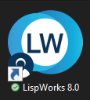

## From the left-top, select File

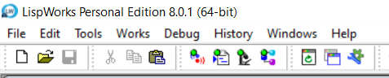

## Select New to open an Editor

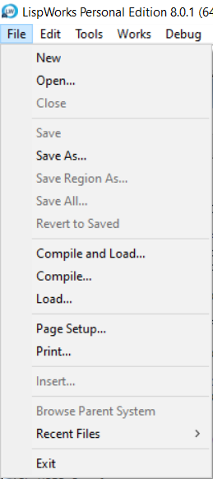

## The Editor is opened

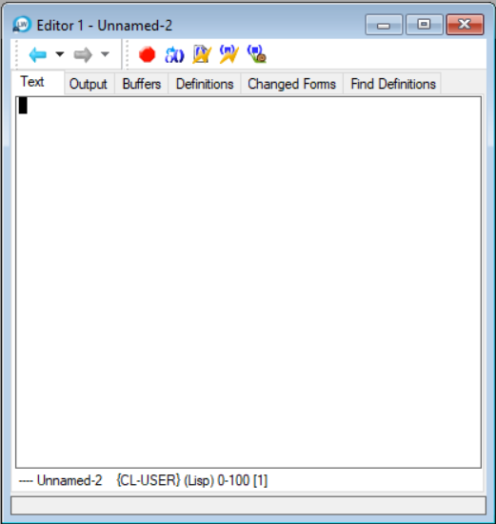

## Write the Lisp code

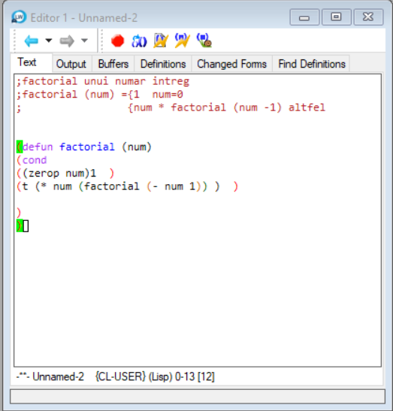

## Click here to compile the code

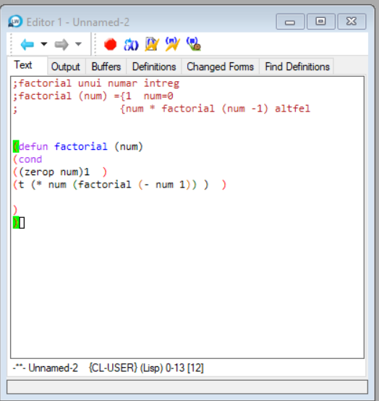

## This shows errors too

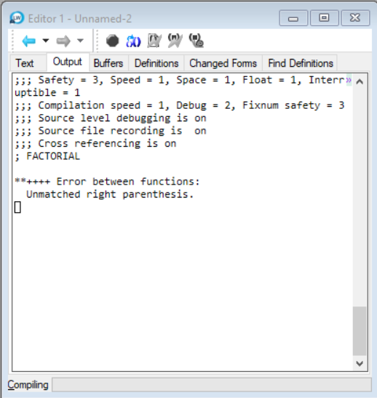

## If there are no errors, you can press Space to continue

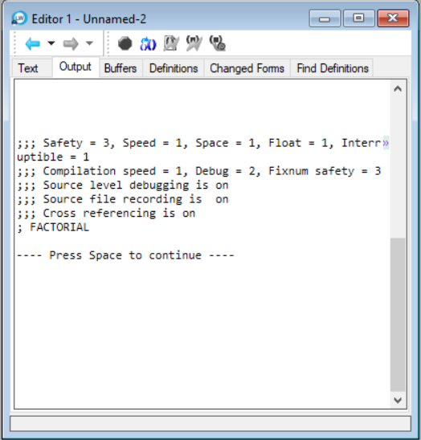

## Open a Listener to run the code



## This is the listener

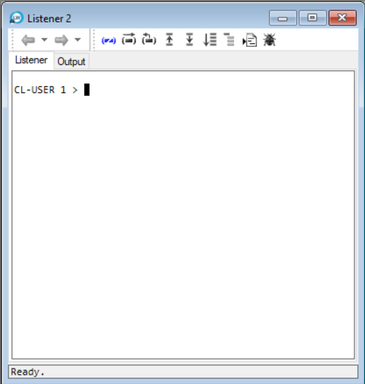

## Now use the function defined in the Editor. The code needs to be compiled.

